Fabric Sculpture
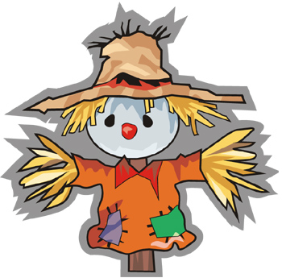


Materials
- Hessian (three colours)
cut into rectangles, squares and circles
- Raffia (natural)
- Calico dyed with tea or coffee
- Acrylic stuffing
- Dowel or strong sticks
- String to bind sticks together
- Rubber bands
- Joggle eyes
- Felt scraps
- Fabric and Leather scraps
- Black pom poms and feathers
- Buttons

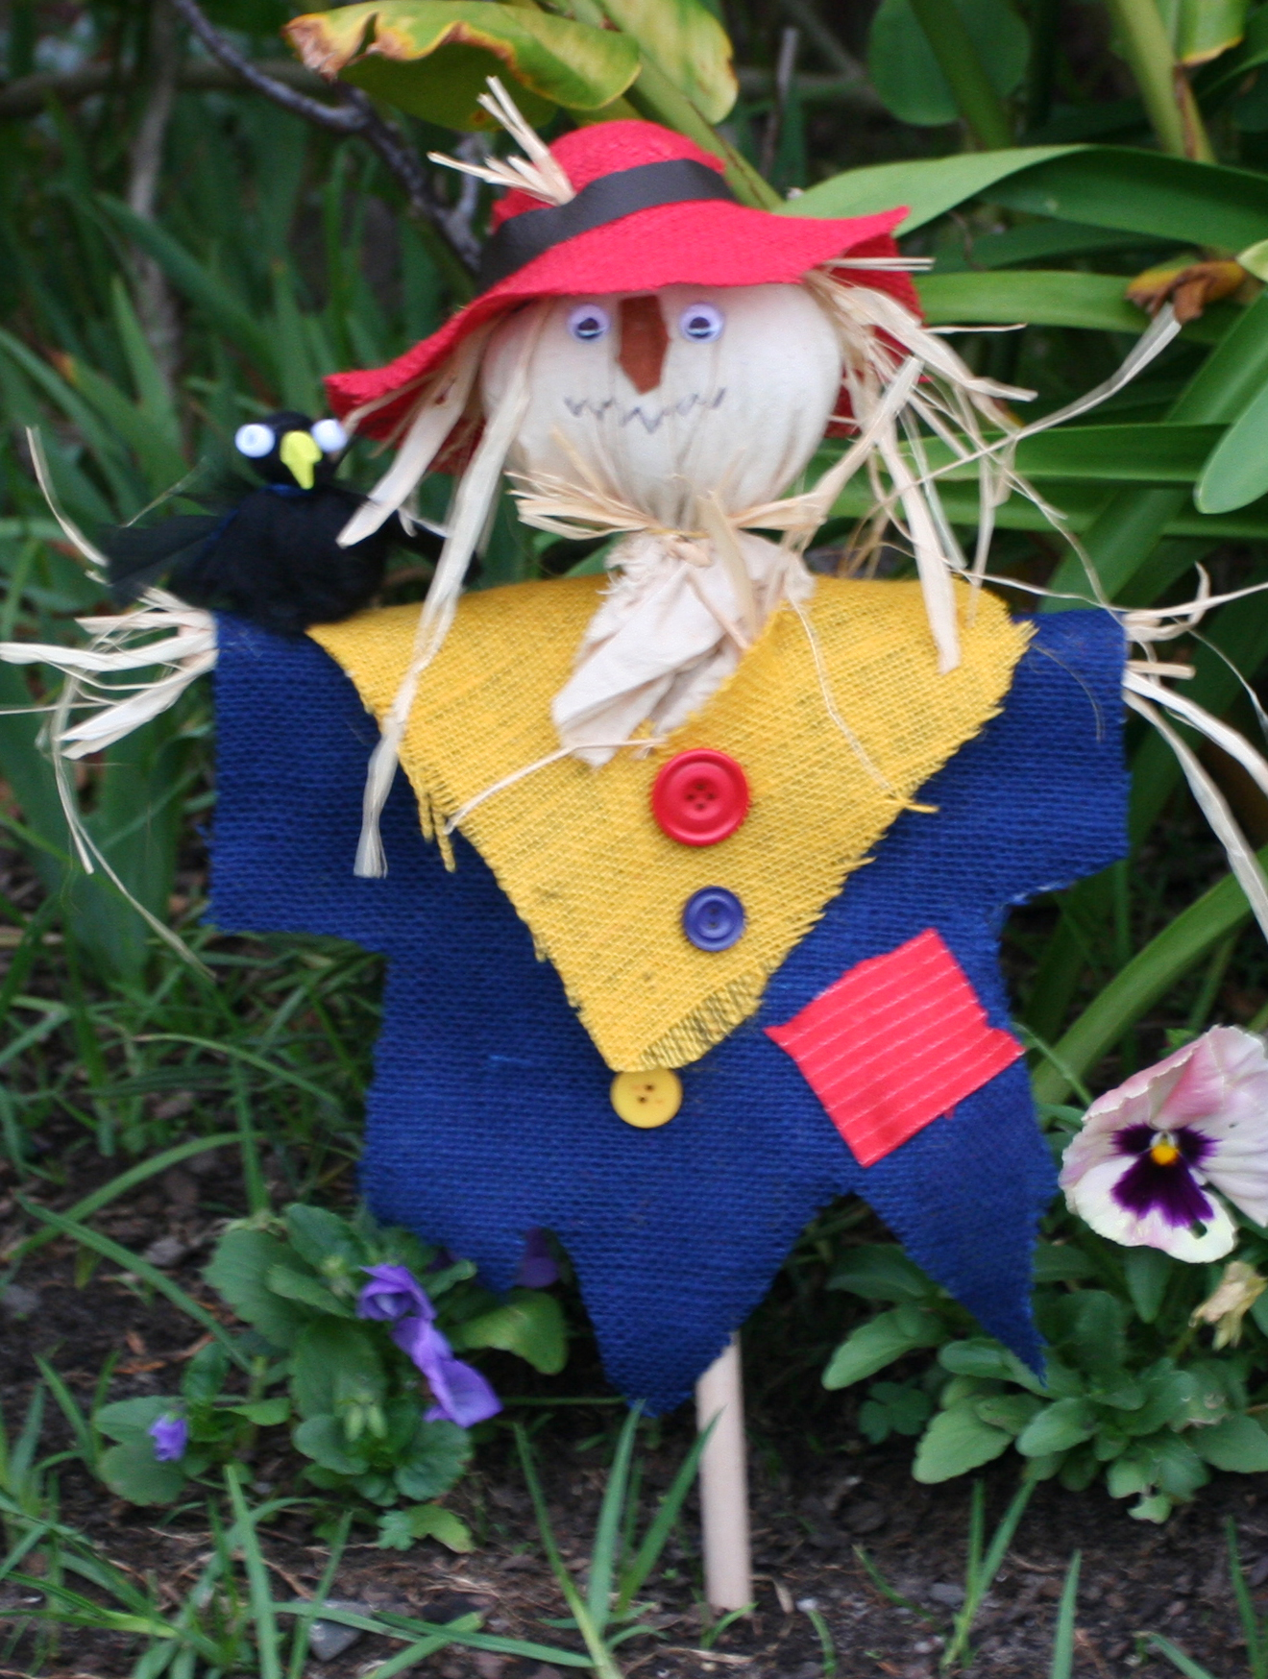
Instructions
- Dye a handkerchief sized piece of calico in coffee or tea and dry it.
- Bind two sticks together with string and tie firmly.
- Cut a rectangle of Hessian, fold in half and cut a small neck hole.
- Slip rectangle over cross and make a smaller similar garment with a square of a different colour. Make a central hole and slip over cross and turn it to form a “v” shape at the front. Slit front if desired.
- Stuff calico and place carefully onto stick as the scarecrow’s head. Secure firmly with a rubber band or two.
- Glue straw onto head and to ends of arms etc.
- Make a hat with 2 circles of Hessian. Larger circle for brim and smaller for crown which should be stuffed and sit inside the larger circle which has a cross cut into it. Make a hat band with leather or ribbon.
- Decorate face with felt nose and joggle eyes. Draw or glue on a mouth. After shaping and gluing the coat shape add patches, pockets, scarf etc
- Add a beady eyed and cheeky pom- pom crow to the cross sticks.

